小精靈

Pac-Man

在這個專案，你要創造一個會從遊戲過程中學習的Scratch小精靈(Pac-Man)遊戲

In this project you will create a Pac-Man game in Scratch that is able to learn from how you play.

你不會告訴小精靈遊戲規則與目標，也不會給指引，你給電腦的是你玩遊戲的範例。

You won’t give it instructions for how to play, or tell it what the objective or rules of the game are.

Instead, you’ll show it examples of you playing the game.

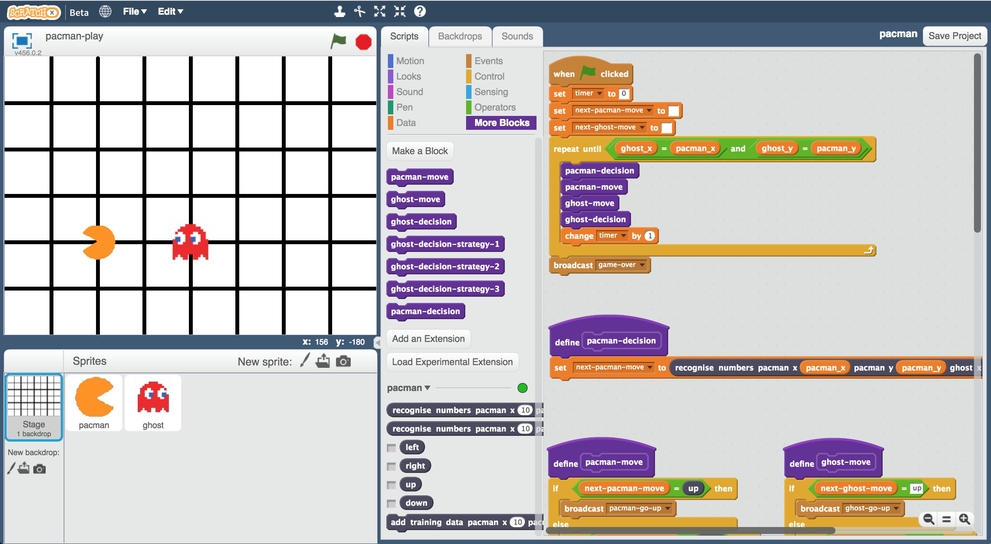

This project worksheet is licensed under a Creative Commons Attribution Non-Commercial Share-Alike License

http://creativecommons.org/licenses/by-nc-sa/4.0/

1. 搜尋網頁：<https://machinelearningforkids.co.uk/scratchx>

Go to <https://machinelearningforkids.co.uk/scratchx> in a browser.

1. 開啟**Pac-Man**專案

*點選****Project templates*** *->* ***Pac-Man***

Open the **Pac-Man** template for this project.   
*Click* ***Project templates*** *->* ***Pac-Man***  
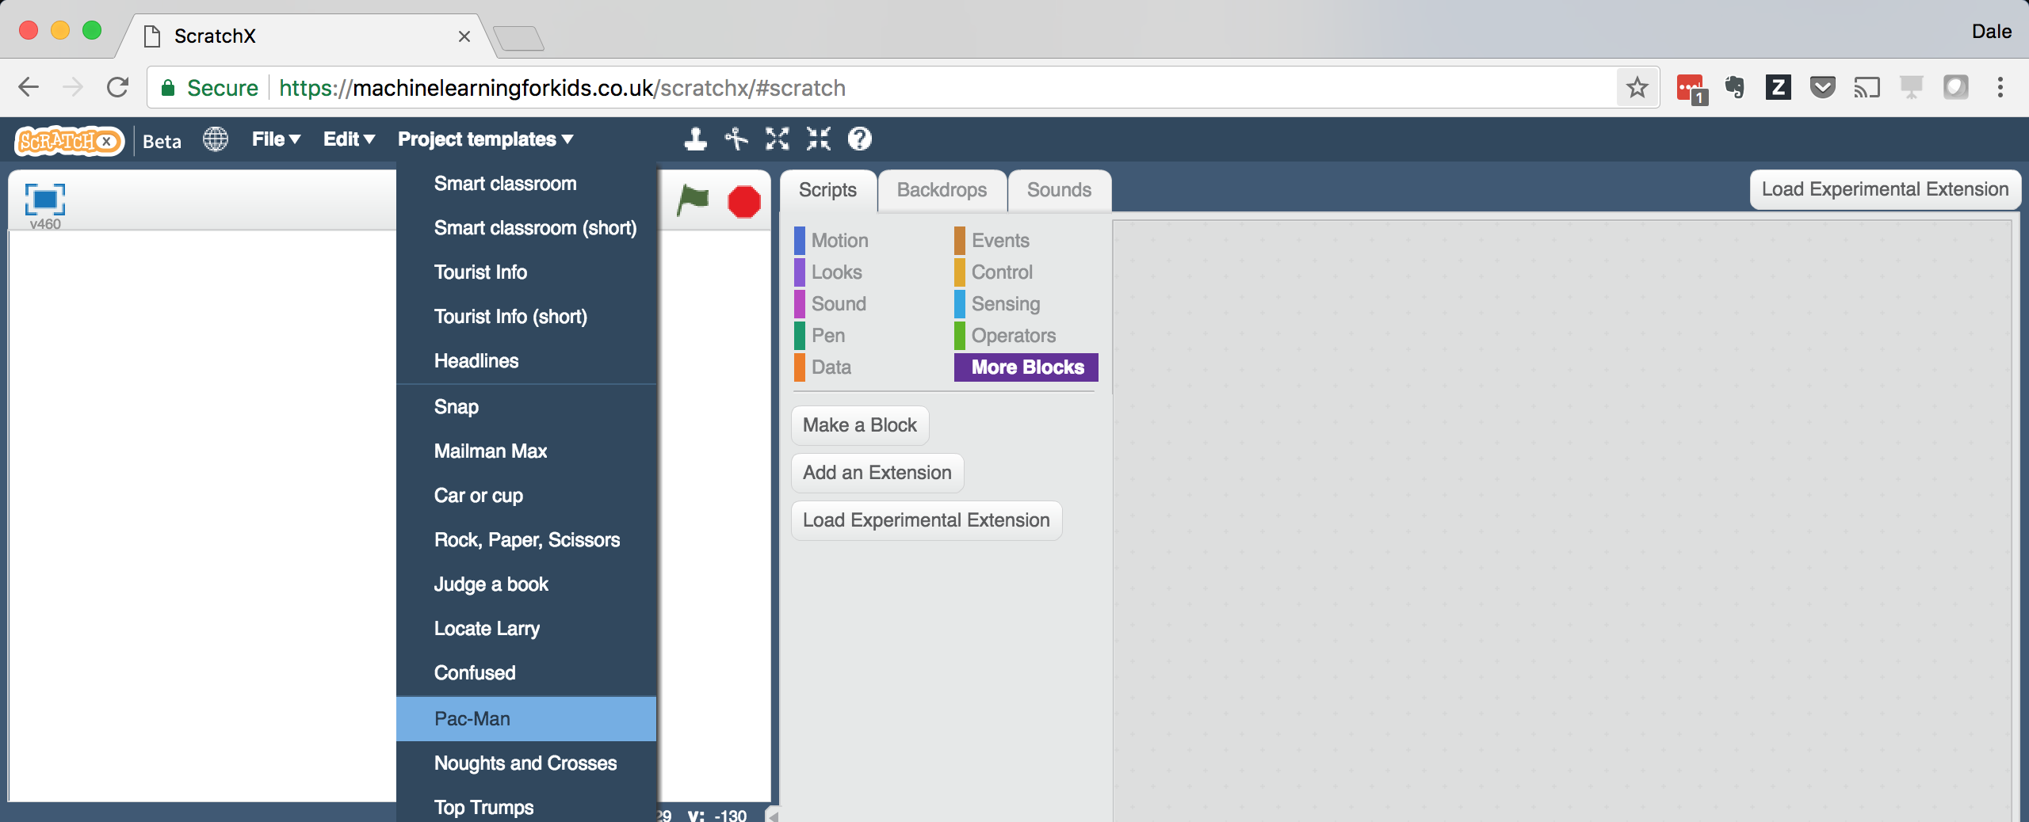

1. 點選全螢幕，再點擊綠旗

Click the **full-screen** button, and then click the Green Flag  
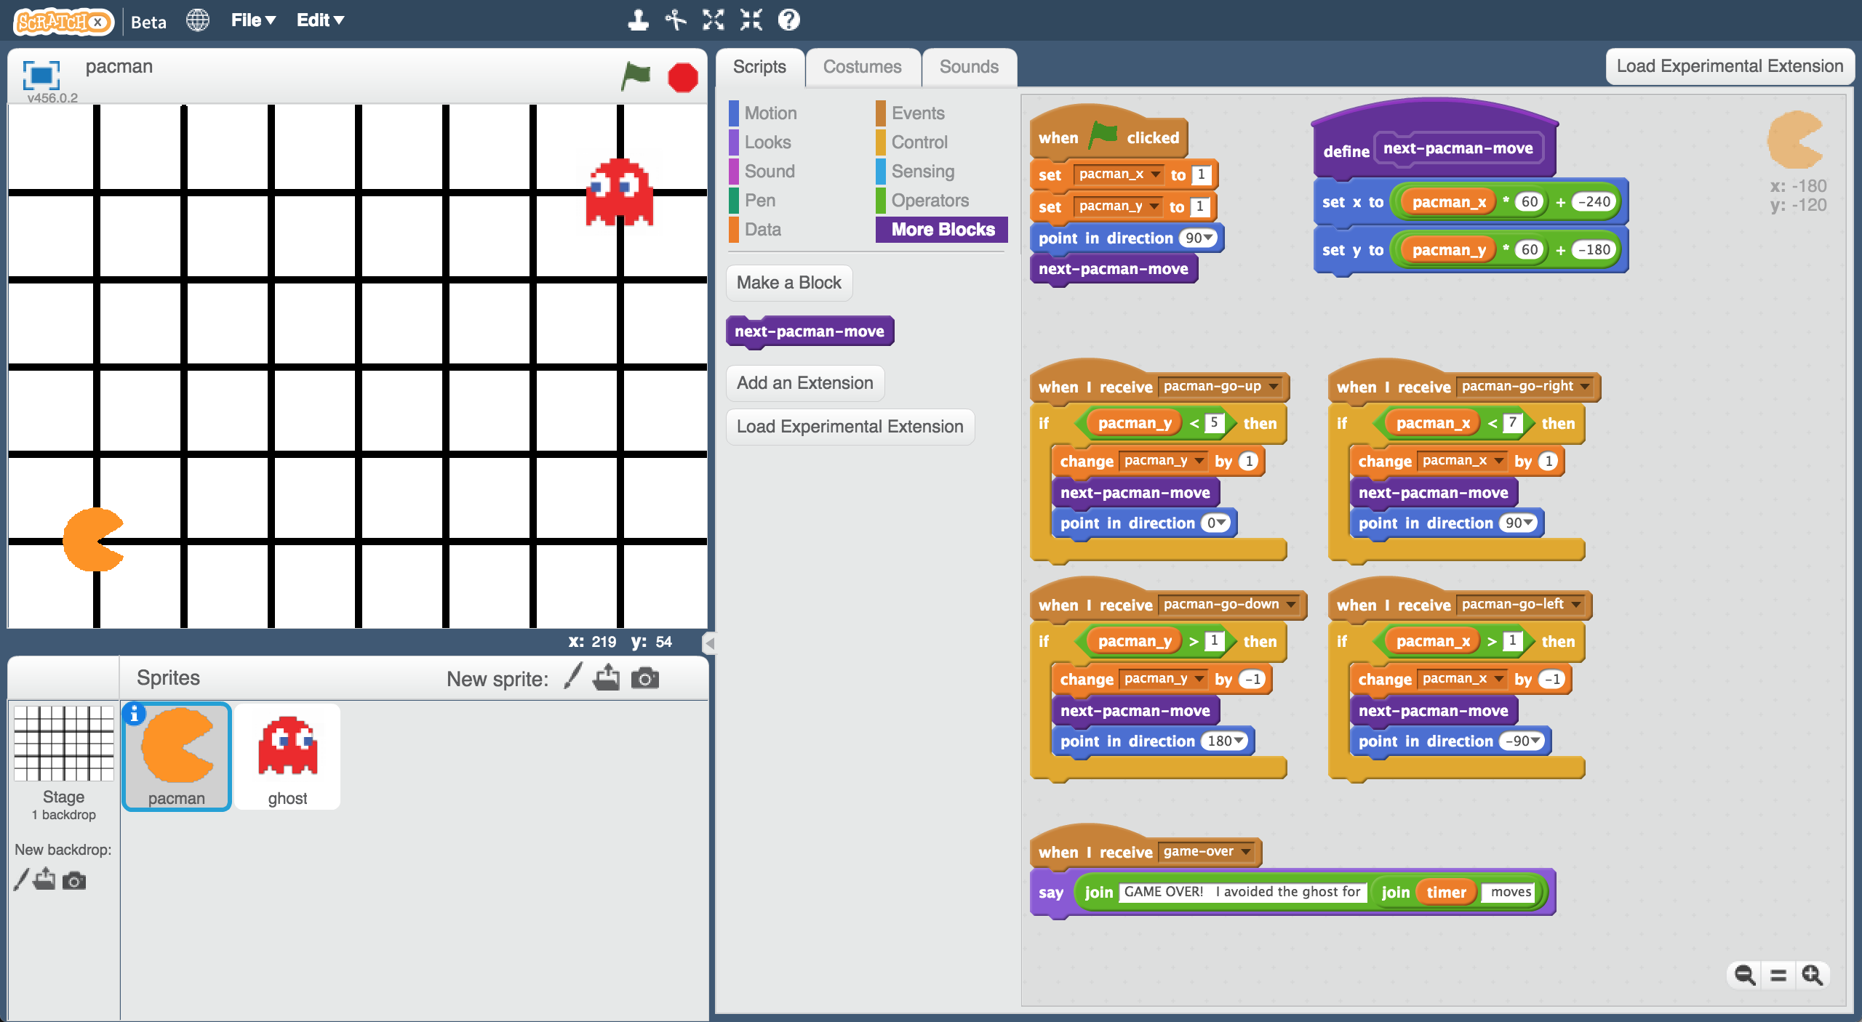

1. 玩一下這個遊戲

*你要控制小精靈，而且要避開鬼。*

*使用方向鍵控制小精靈的移動方向。*

*點擊綠旗重新開始遊戲。*

Play a few games of Pac-Man  
*You control Pac-Man, and have to avoid the ghost as long as you can.   
Use the arrow keys to control Pac-Man’s next move.*   
*Click the green flag to start a new game.*

1. 試著研究出一套遊戲攻略讓小精靈避開鬼

Try to come up with a plan for how Pac-Man can avoid the ghost

用Scratch玩小精靈遊戲

Representing Pac-Man in Scratch

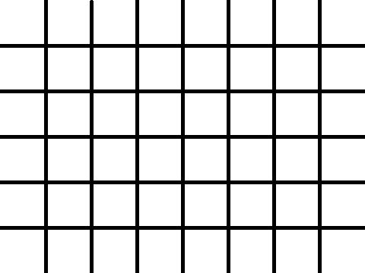



up

right

left

down

每回移動，每個角色都要從上、下、左、右中選一個動作執行。

（沒有對角線移動）

遊戲棋盤是一張圖，小精靈和鬼都只能沿著線移動。

角色位置表示法：

*用一個1~7的值表示x座標

*一個1~5的值表示y座標

舉例：左圖中鬼的位置表示成：

X = 5

Y = 2

y values

1

2

3

4

5

x values

7

6

5

4

1

2

3

**接下來要做什麼？**

**What are you going to do?**

你要給電腦一些遊戲過程範例來訓練小精靈避開鬼

You’re going to train Pac-Man to avoid the ghost. You’ll do this by showing it examples of how you play the game.

想像遊戲畫面長這樣：

Imagine the board looks like this:

假設你決定下一步往下走：

Imagine you decide to go down:

想像遊戲畫面長這樣：

Imagine the board looks like this:

假設你決定下一步往上走：

Imagine you decide to go up:

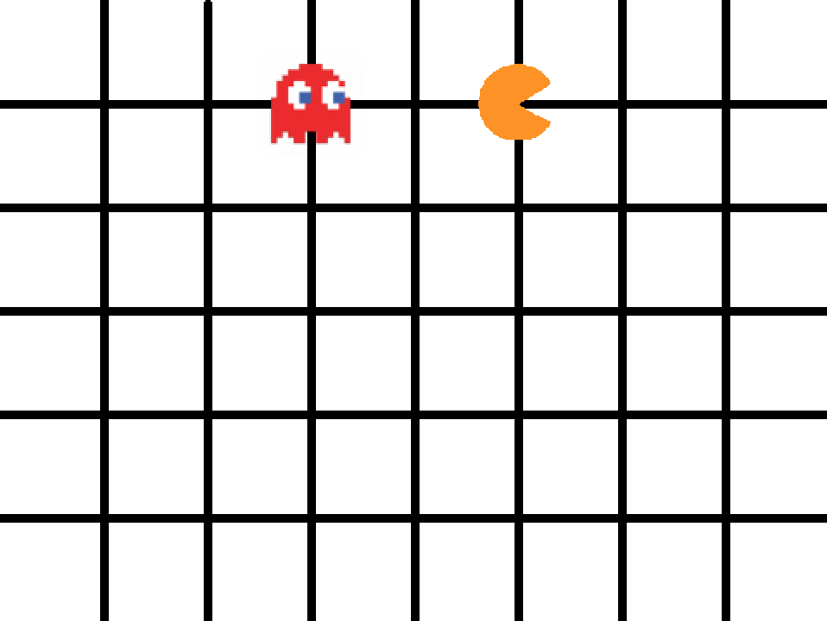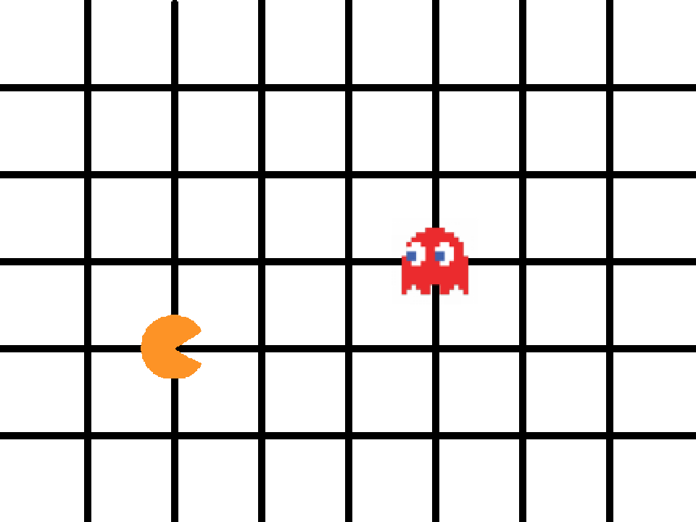

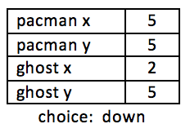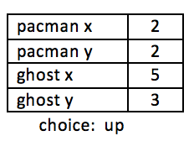

電腦會從遊戲過程裡你下的每個決定學習

The computer will learn from the decisions that you make when you play the game.

如果你可以讓小精靈長時間避開鬼移動，那麼電腦應該就能學會如何避開鬼！

If you make moves that avoid the ghost for a long time, the computer should learn how to avoid the ghost!

1. 關閉Scratch視窗

Close the Scratch window.

1. 搜尋網頁：<https://machinelearningforkids.co.uk/>

Go to <https://machinelearningforkids.co.uk/> in a web browser

1. 點選“**Get started**”按鈕

Click on “**Get started**”

1. 點選“**Log In**”按鈕並登入系統

*如果你沒有帳號，請你的老師幫你建立一個帳號。*

*如果你不記得你的帳號或密碼，請你的老師幫你重新設定一次。*

Click on “**Log In**” and type in your username and password  
*If you don’t have a username, ask your teacher or group leader to create one for you.  
If you can’t remember your username or password, ask your teacher or group leader to reset it for you.*

1. 點選上方清單中的 **”Projects”** 按鈕

Click on “**Projects**” on the top menu bar

1. 點選 “**+ Add a new project**” 按鈕

Click on the **“+ Add a new project**” button.

1. 將你的專案命名為 “pacman”並設定成辨識 “**numbers**”類別

Name your project “pacman” and set it to learn how to recognise “**numbers**”  
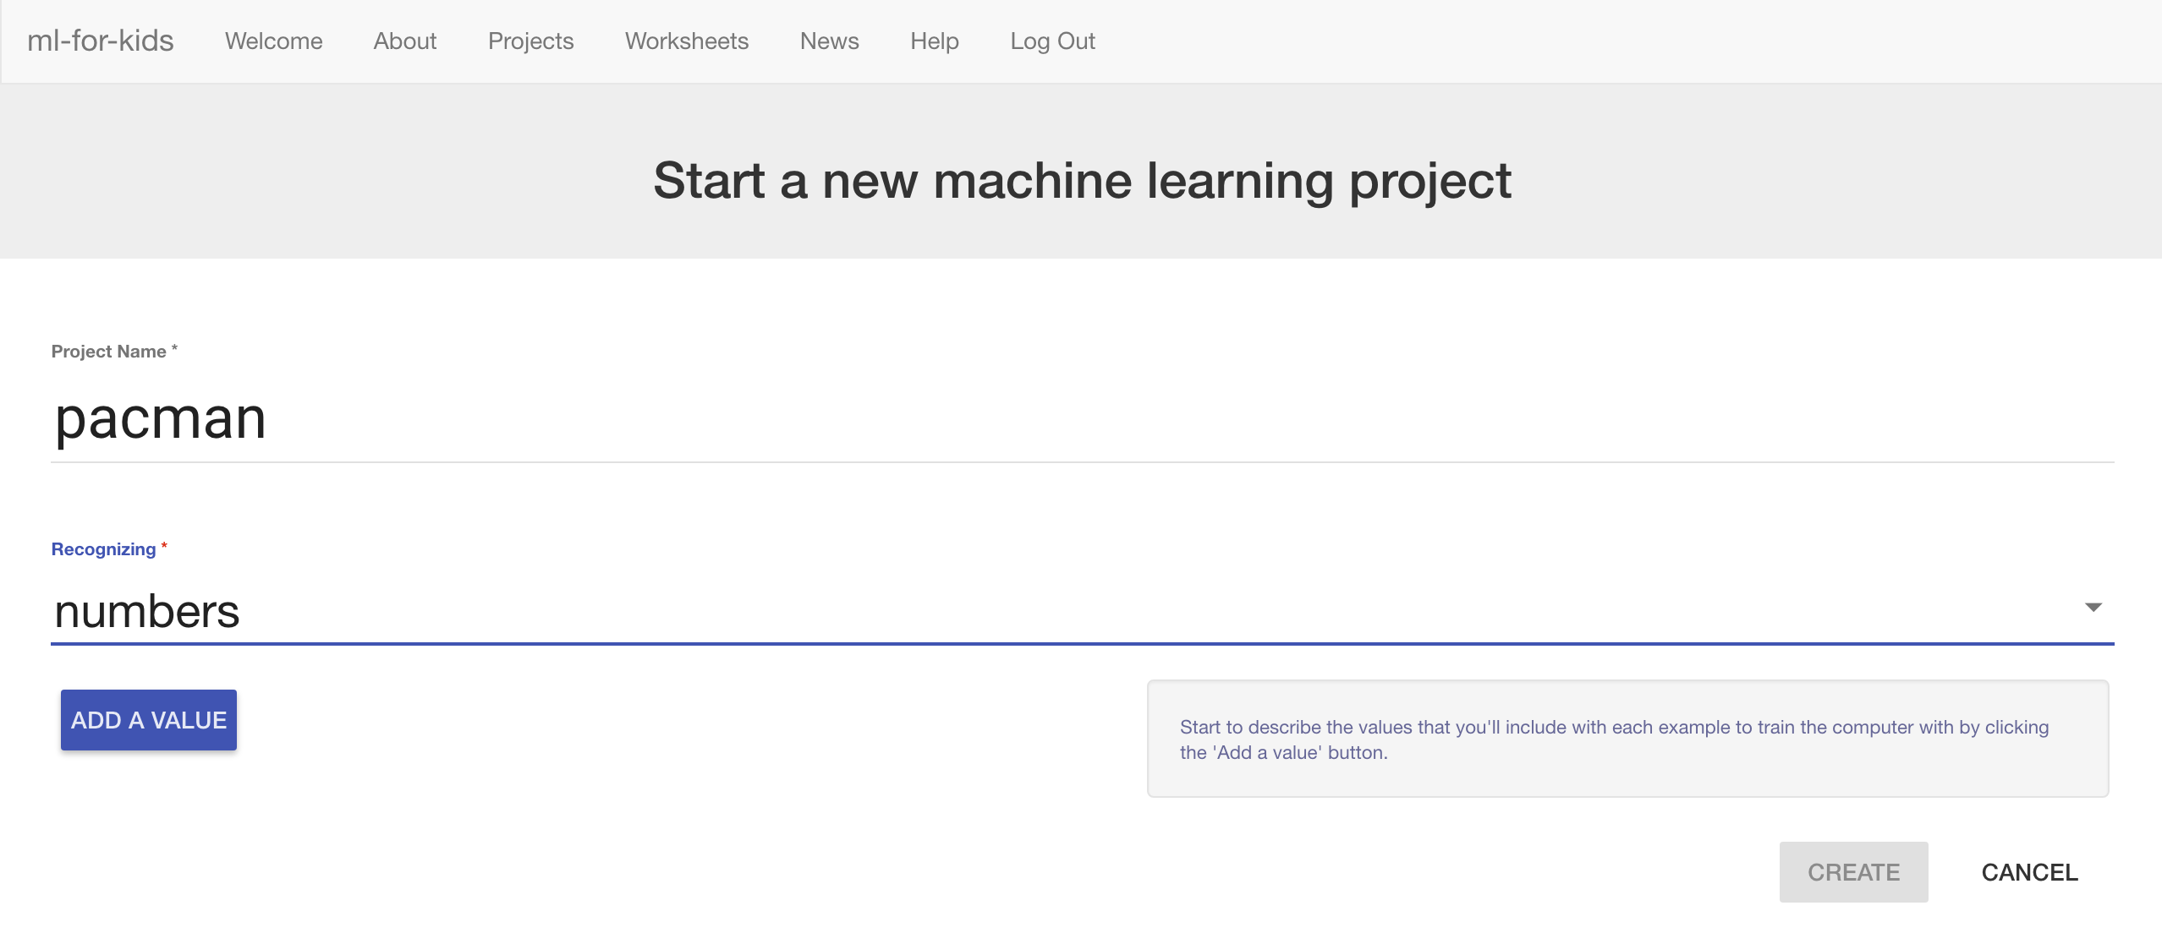

1. 點選“**Add a value**”按鈕，命名為“pacman x”，類別選擇 “number”

Click “**Add a value**” and name a value “pacman x” and make it a “number”.  
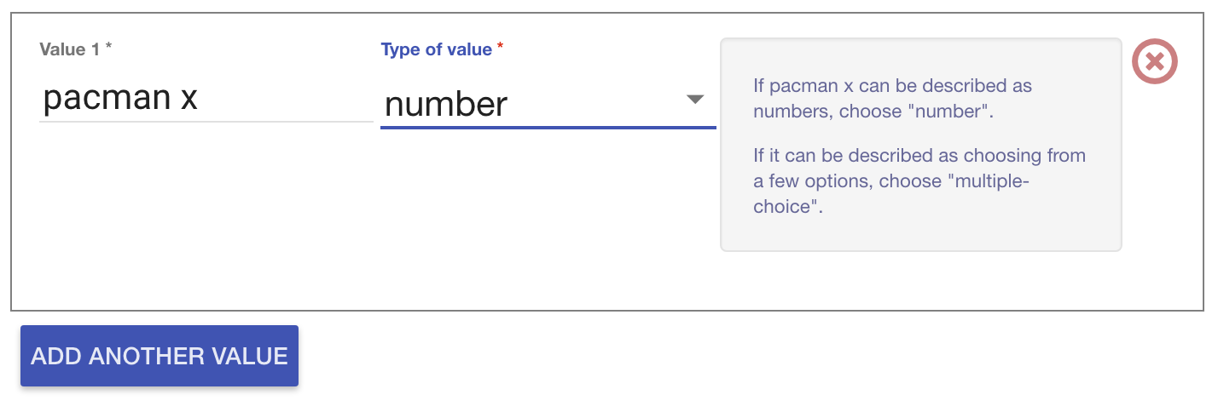

1. 點選“**Add another value**”，加入其他三個：“pacman y”、 “ghost x”和“ghost y”

Click “**Add another value**” again and repeat to add values for the other three positions: “pacman y”, “ghost x”, “ghost y”  
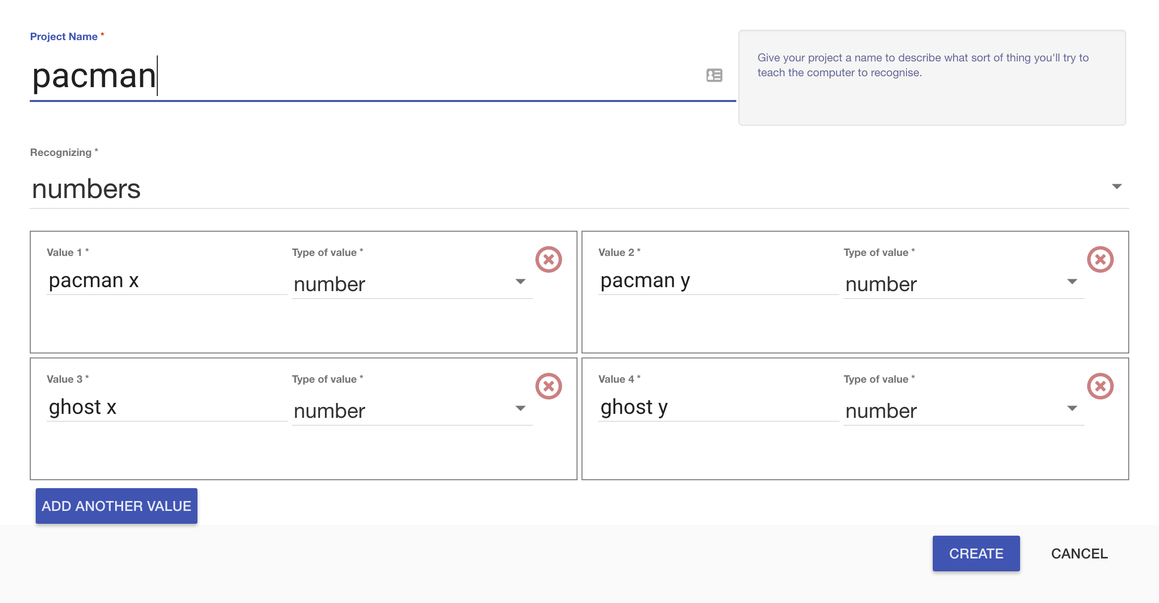

1. 點選**Create**按鈕

Click **Create**.

1. 你會在專案清單中看到“**pacman**”，點選此專案

You should see “**pacman**” in the list of your projects. Click on it.  
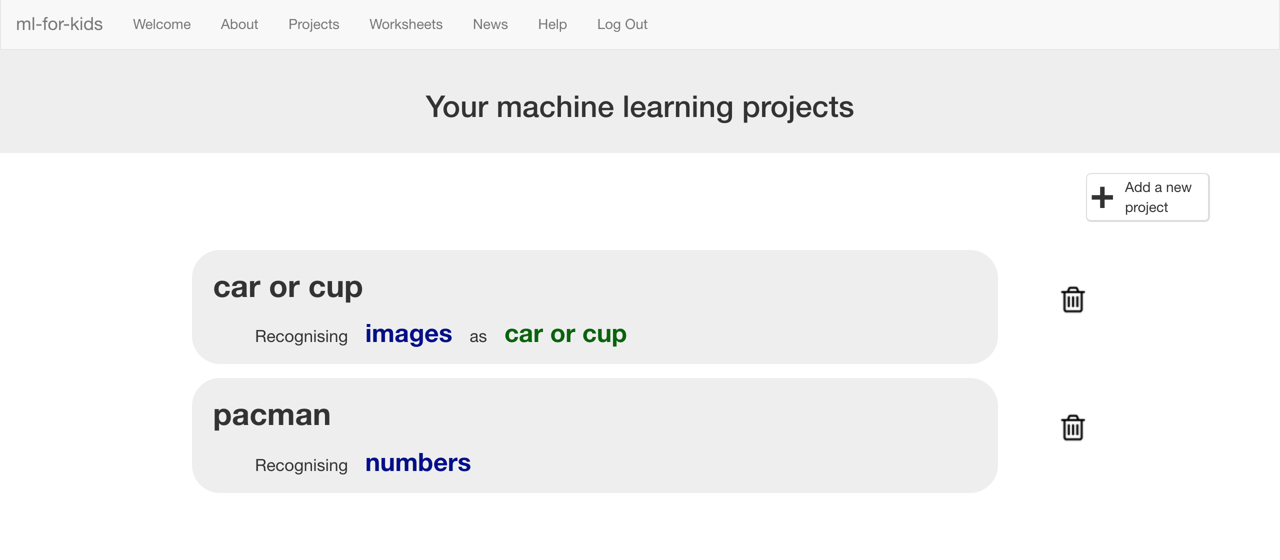

1. 點選 **”Train”** 按鈕

Click the “**Train**” button  
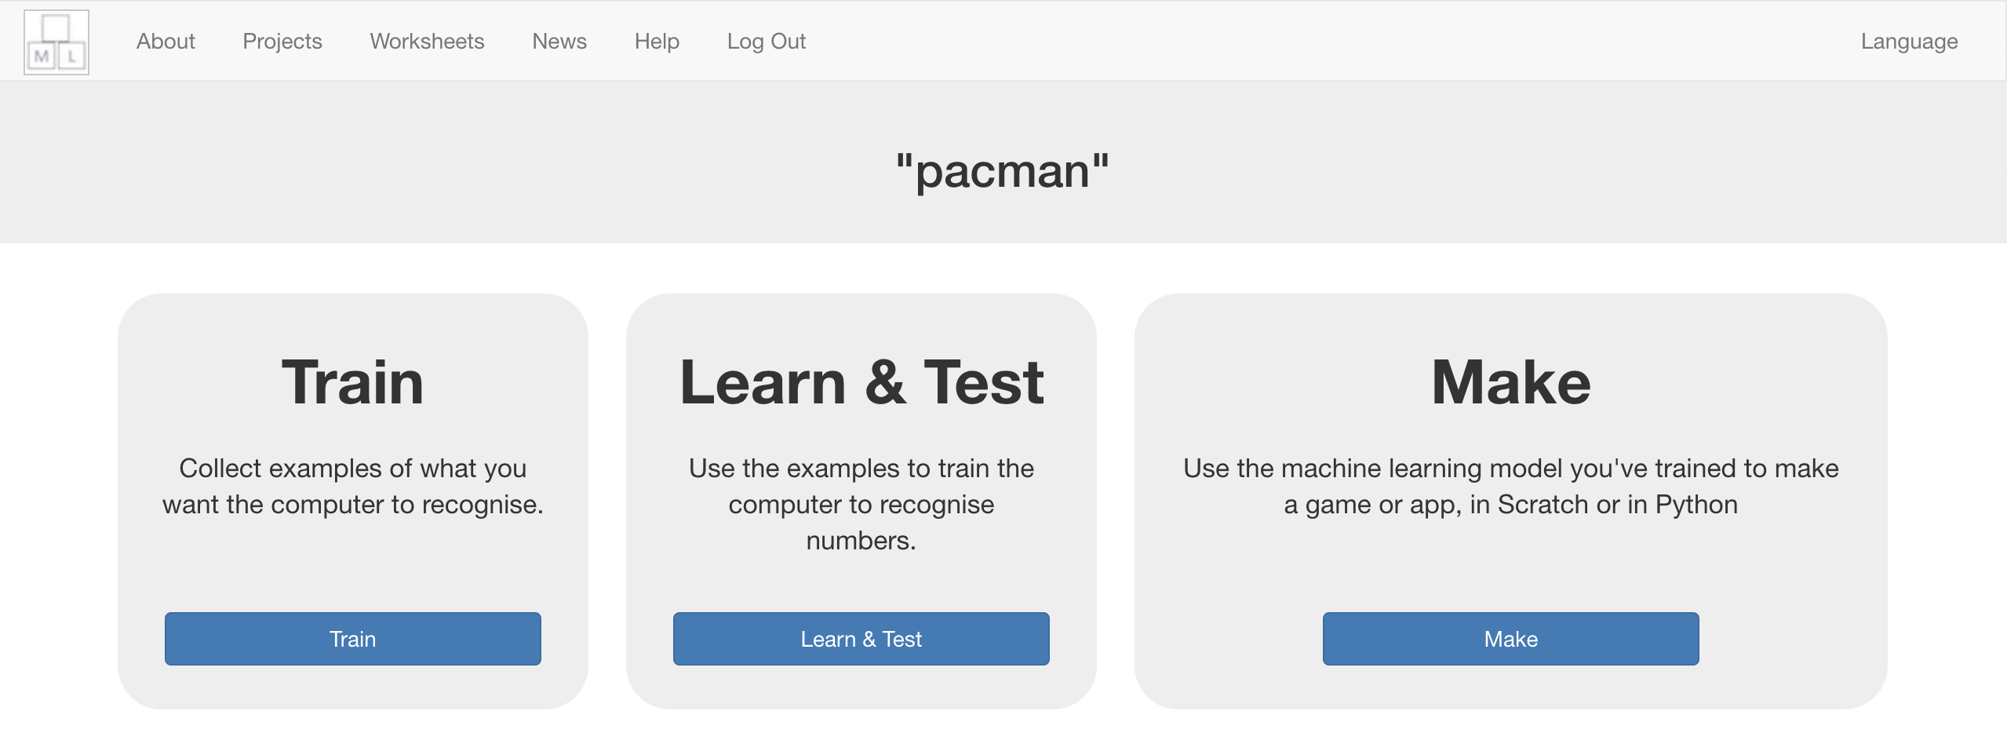

1. 點選**+ Add new label**按鈕，將標籤命名為：left

*範例遊戲裡，當你選擇向左走時，小精靈和鬼的位置會儲存在這個方框*

Click “**+ Add new label**” and create a label called “left”  
*Examples of the locations of the Pac-Man and ghost when you go left will go in this bucket.*   
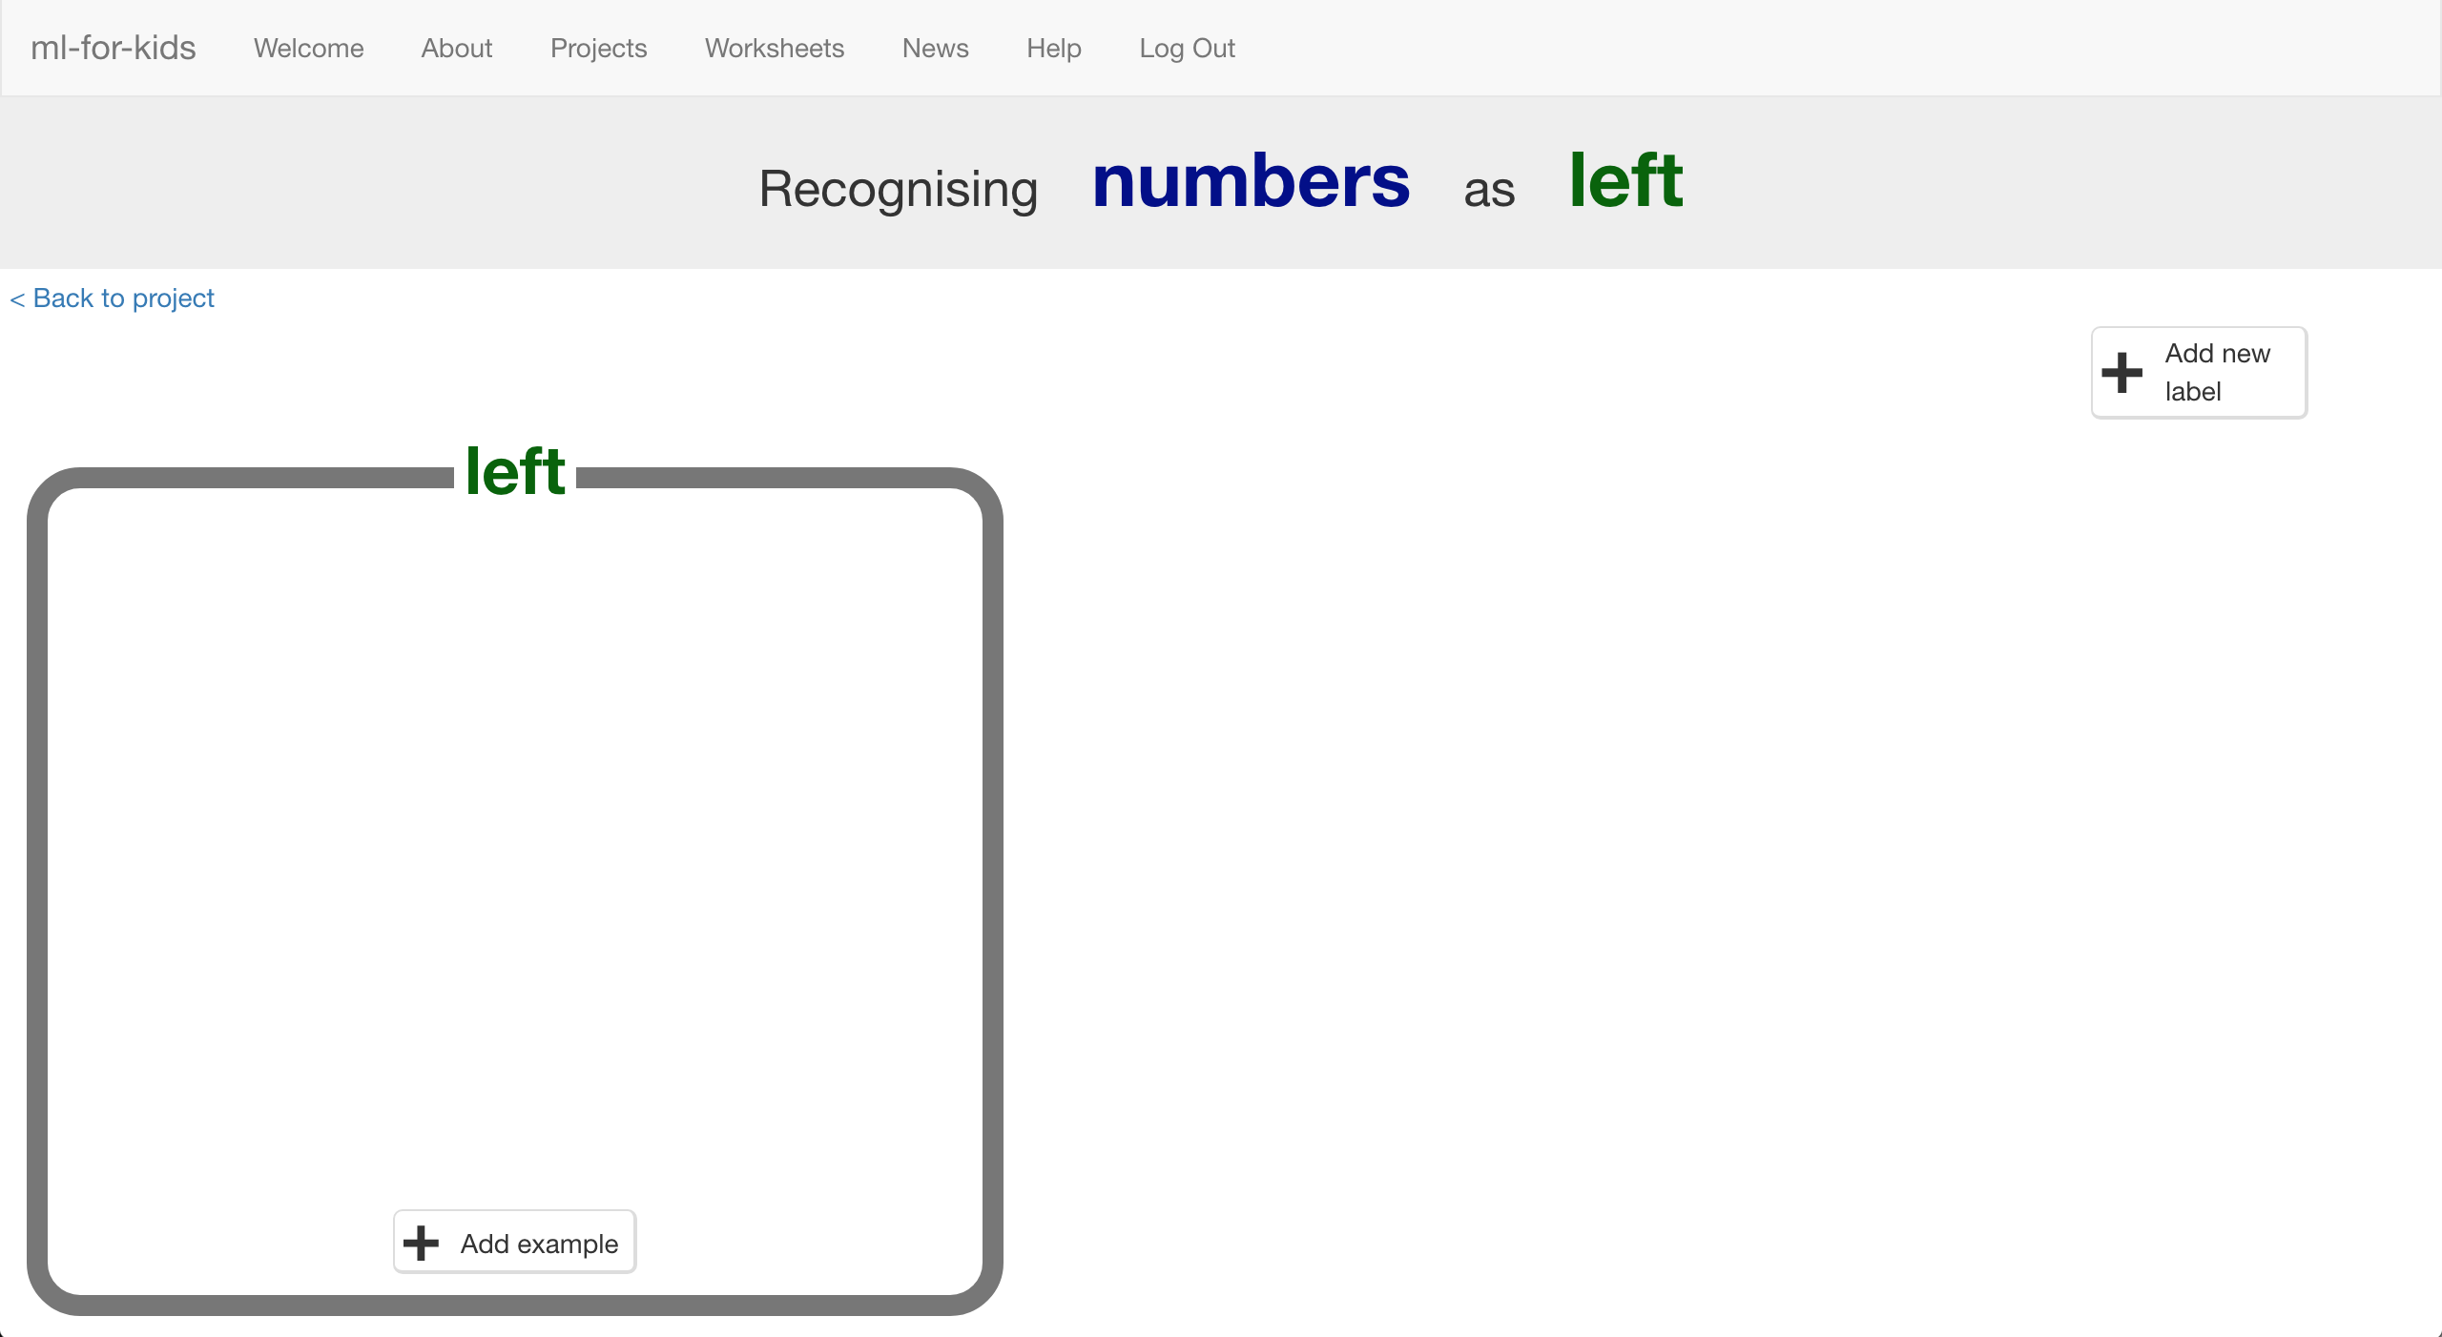

1. 點選**+ Add new label**按鈕，新增其他三個動作：*right*、*up*、*down*

Click “**+ Add new label**” again and create labels for the other three moves in the game.  
*“right”, “up”, “down”*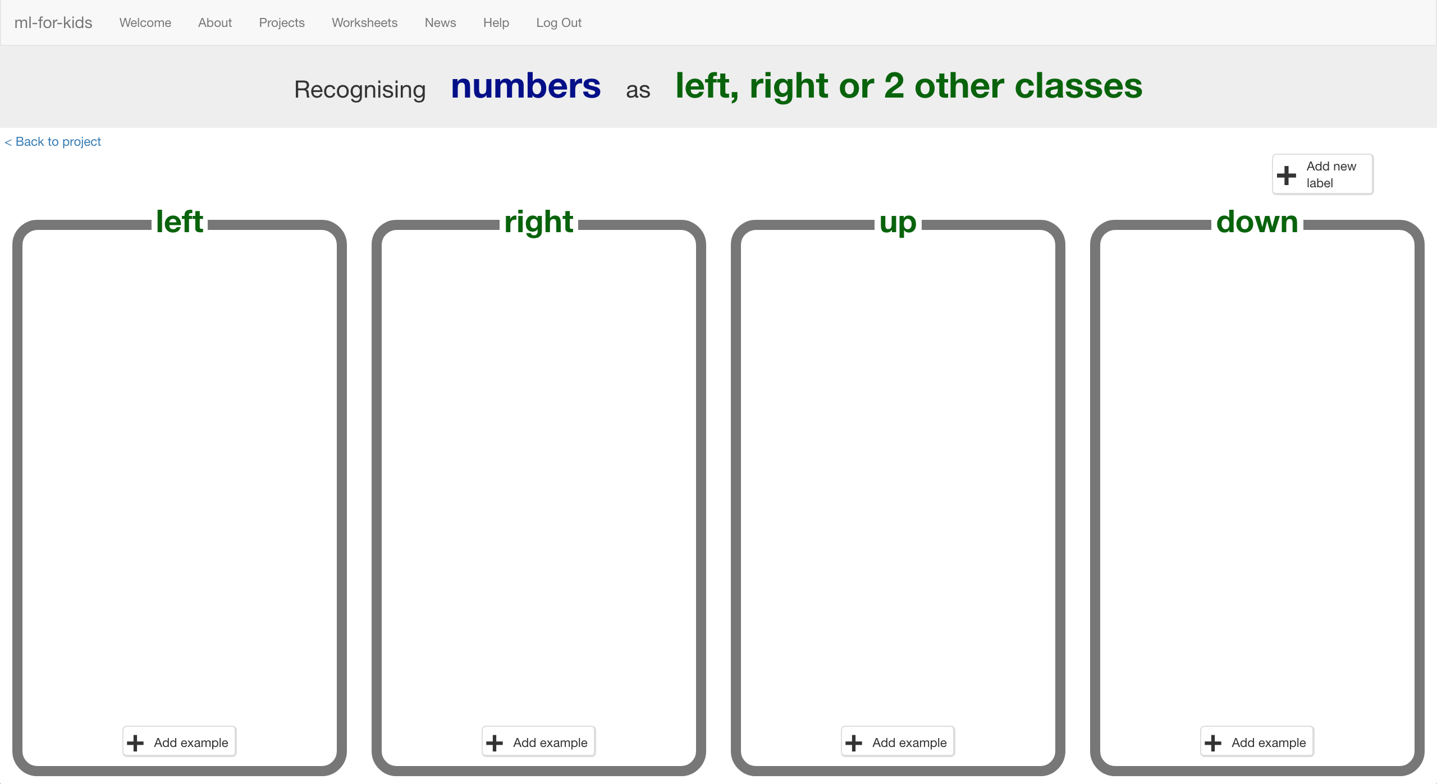

1. 點選“**< Back to project**”

Click the “**< Back to project**” link

1. 點選**Make**按鈕，再選擇**Scratch**

Click the “**Make**” button then click the “**Scratch**” button

1. 點選**Straight into Scratch**按鈕

*這時會出現一個警告，提醒你還沒有訓練電腦，但這沒關係，因為我們要用Scratch來搜集訓練用的範例。*

Click the **Straight into Scratch** button  
*It will warn you that you haven’t trained the computer yet – but that’s okay, as you’ll use Scratch to collect the training examples.   
*

1. 你可以在專案裡的『更多積木』(More blocks)區看到新積木

You should see new blocks in the “**More blocks**” section from your “pacman” project.  
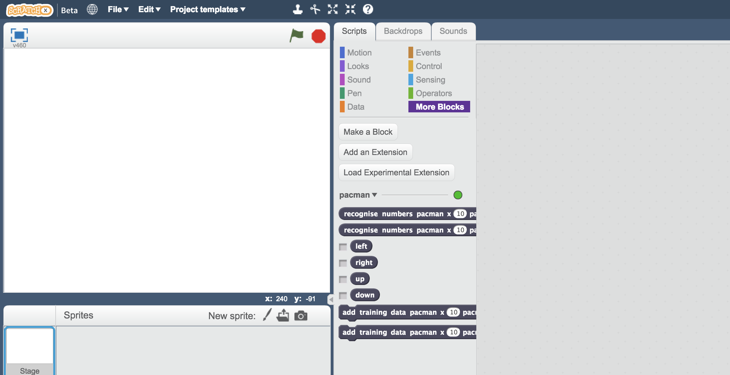

1. 再次開啟Pac-Man專案

*點選****Project templates*** *->* ***Pac-Man***

Open the Pac-Man template project again.  
*Click* ***Project templates*** *->* ***Pac-Man***

1. 點選『舞台』，在程式碼中尋找以『當綠旗被點擊』為開頭的積木，此段程式碼用來設定“left”、“right”、“up”、 “down”變數

Click on the “**Stage**” and find the “when green flag clicked” script that sets the “left”, “right”, “up”, “down” constants  


1. 拖曳程式積木更新此段程式碼：使用pacman專案的新積木（如下圖）

Modify the script to use your new blocks from the pacman project  
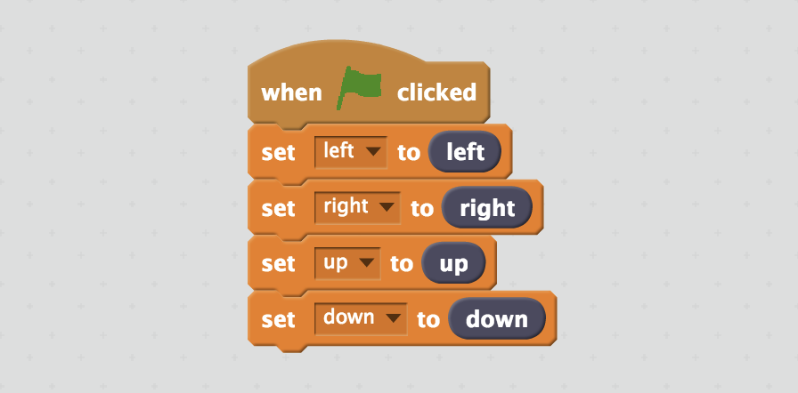

1. 找到pacman-decision為開頭的這段程式碼

Find the custom block “pacman-decision”  
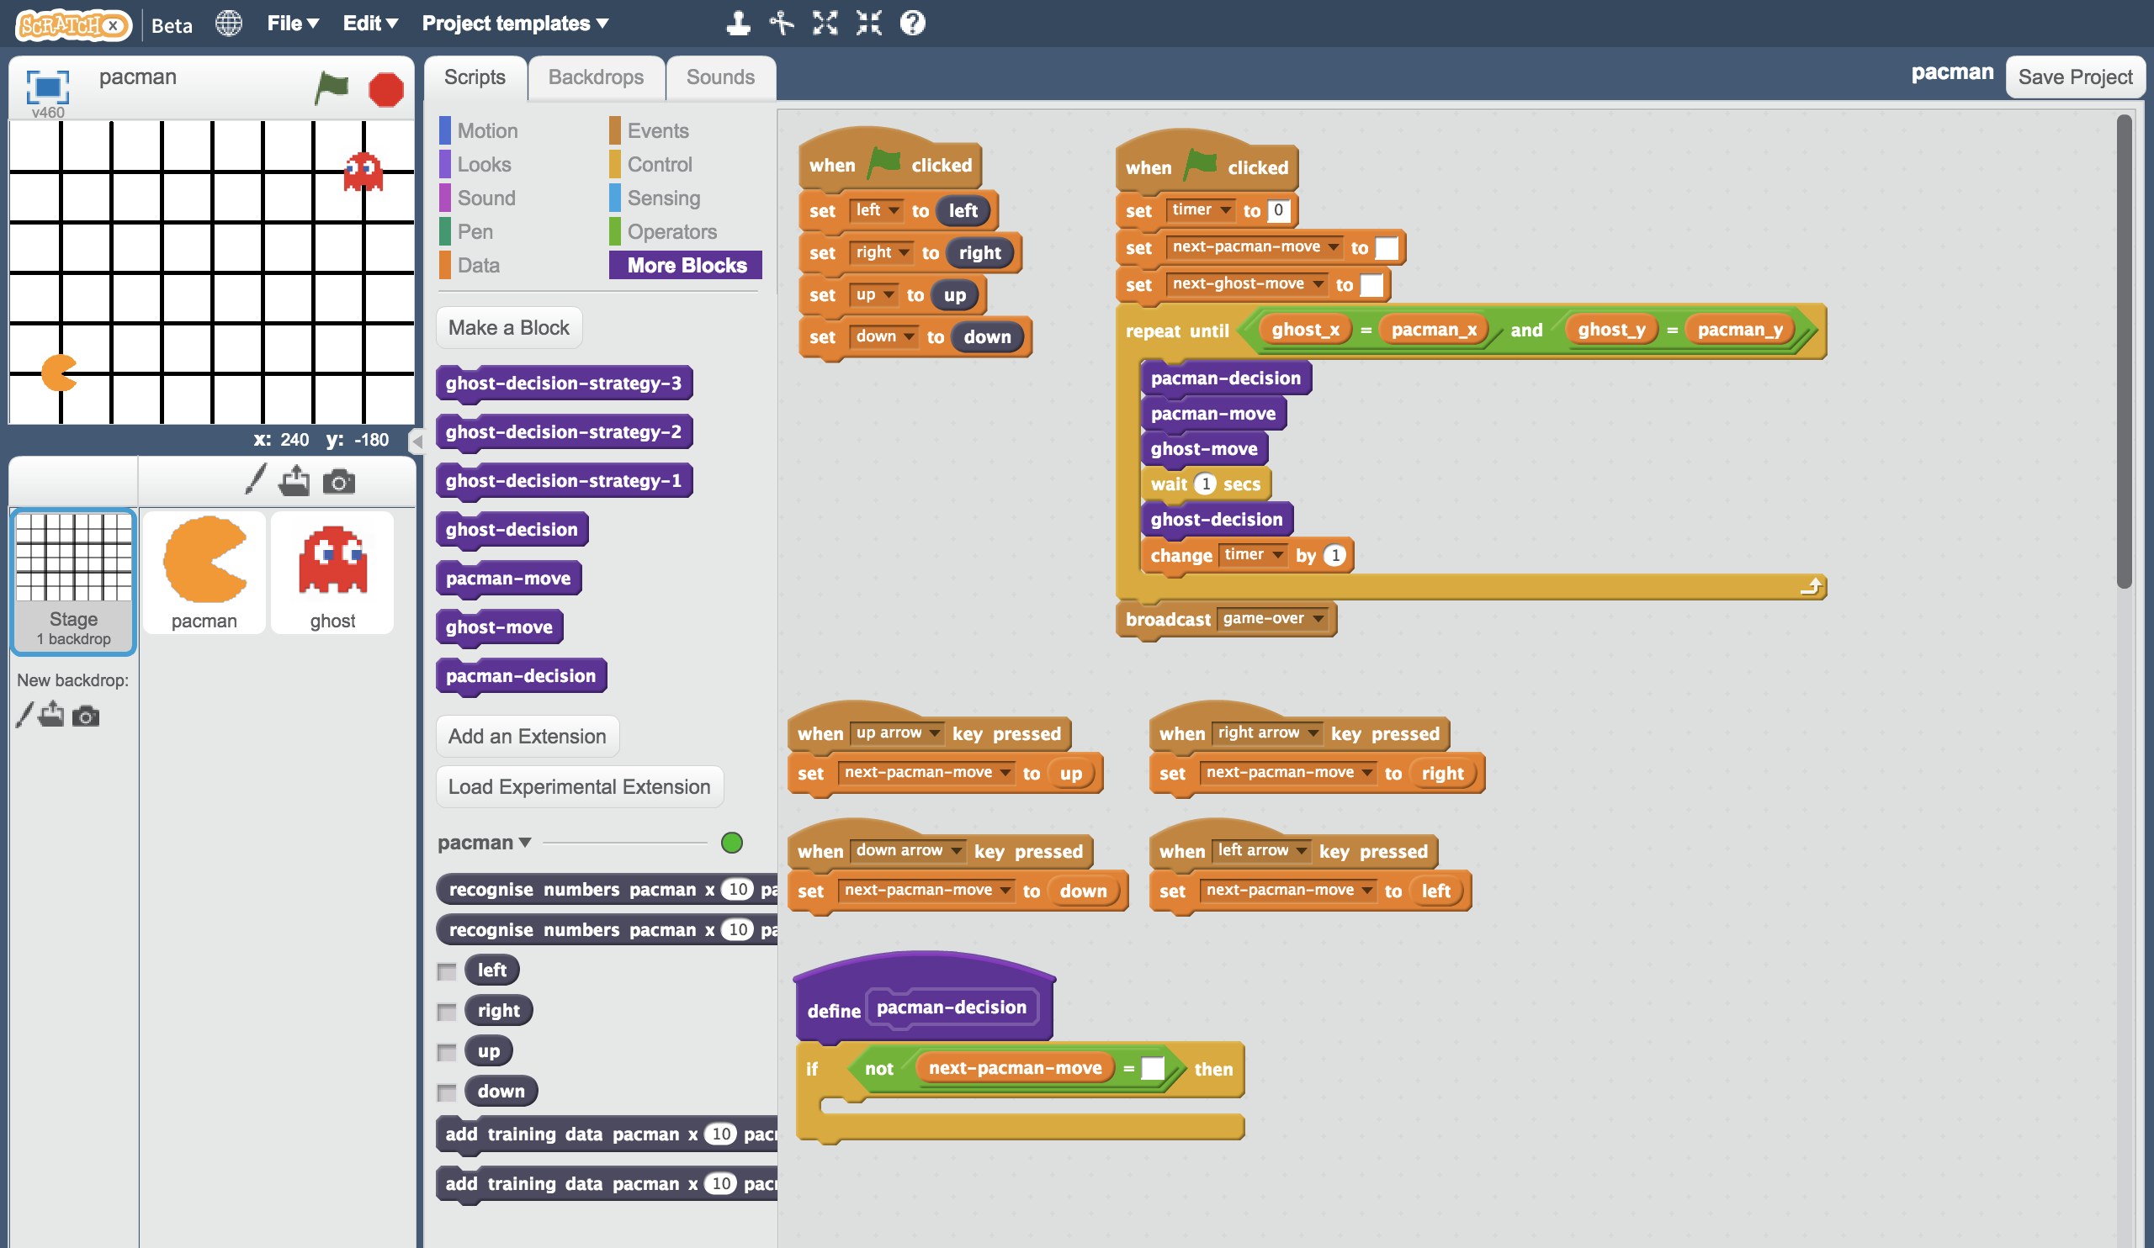

1. 拖曳程式積木更新此段程式碼：加入遊戲過程的每個動作至訓練資料中（如下圖）

Update the “**pacman-decision**” block to add every move you make to your machine-learning training data  
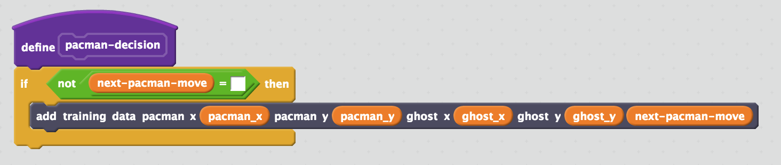

1. 我們要用玩遊戲的方式來訓練電腦！

*選擇全螢幕，再點擊綠旗。*

*玩幾次遊戲，盡全力避開鬼！你玩得越好，電腦就有越好的範例可以學習*

Train the computer by playing the game!   
*Click on full-screen again, and then the Green Flag.   
Play a few games of Pac-Man, doing your best to avoid the ghost.   
The better you play, the better moves the computer has to learn from.*

1. 存檔

*點選檔案，再點選另存專案，檔案命名成pacman-learn，用來提醒自己這個版本是拿來訓練小精靈用的。*

Save your project  
*Click* ***File*** *->* ***Save project*** *Name the file “pacman-learn.sbx” to remind yourself that this version of the project is the one to train Pac-Man.*

1. 回到訓練視窗

Go back to the training tool

1. 點選“**< Back to project**”按鈕，再點選“**Train**”

*你應該會看到一些訓練範例，這是從剛剛你玩遊戲的過程蒐集來的。*

Click the “**< Back to project**” link, then click the “**Train**” button  
*You should see the training examples you collected by playing Pac-Man.  
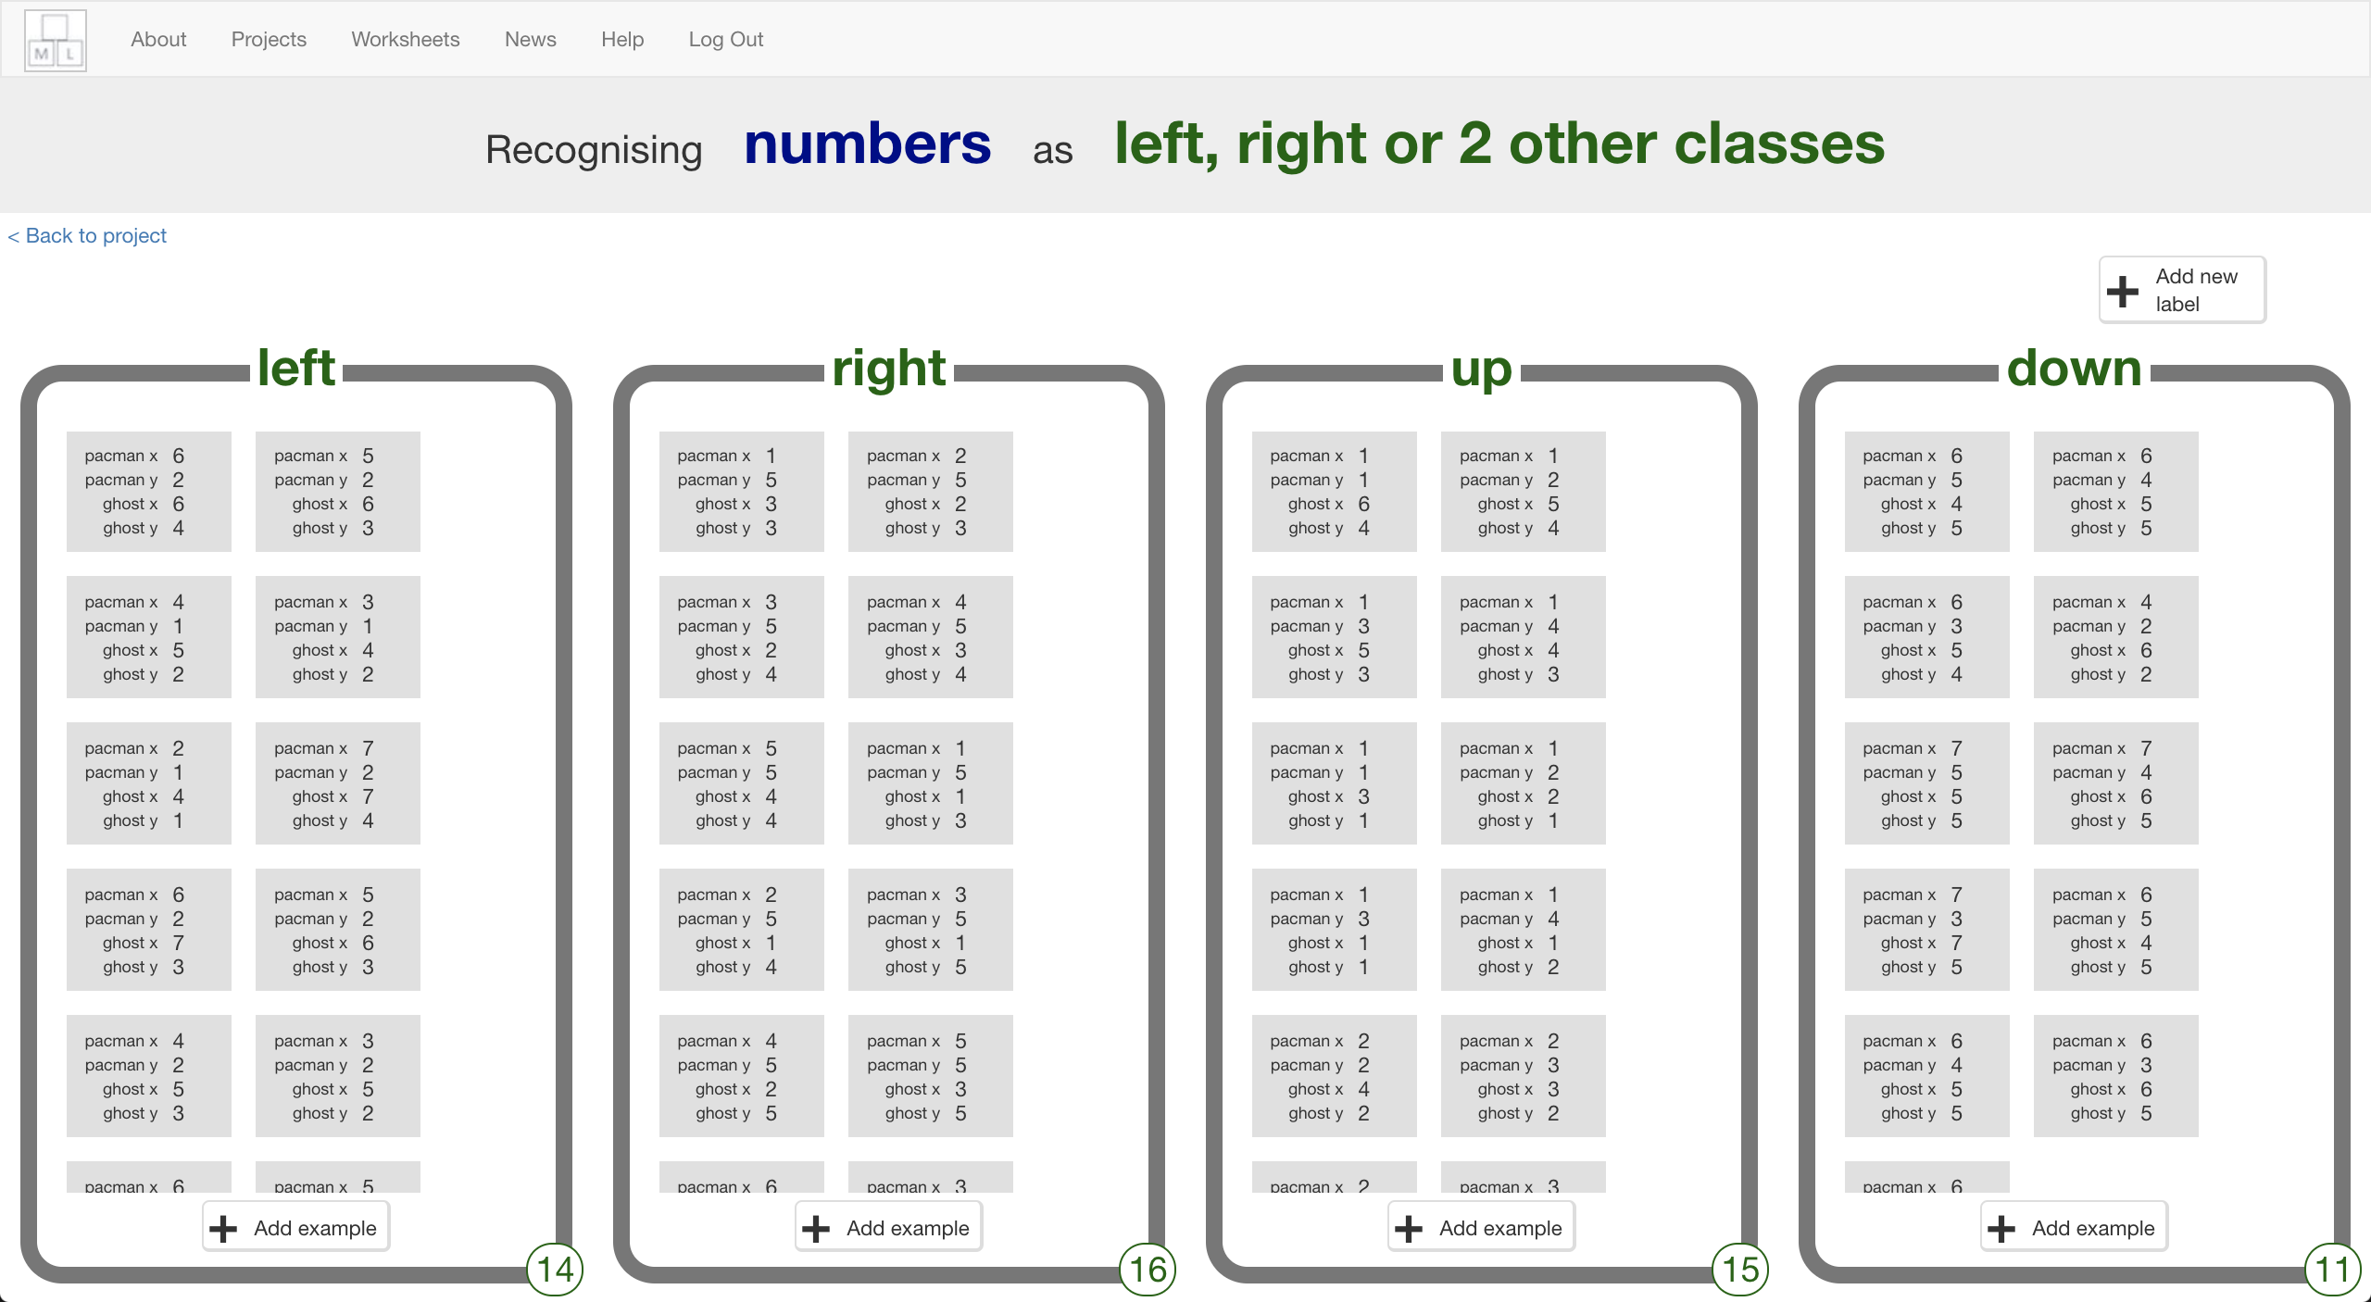*

**到目前為止，你做了哪些事情？**

**What have you done so far?**

你在訓練電腦玩小精靈遊戲。

You’re teaching a computer to play Pac-Man.

你更新了Scratch的小精靈遊戲，讓他可以蒐集範例並加到訓練資料中，你會使用這些範例來訓練一個機器學習『模型』。

You updated a Scratch Pac-Man game so that it can collect examples of how you play and add them to a set of examples. You’ll use those examples to train a machine learning “model”.

1. 點選“**< Back to project**”按鈕

Click the “**< Back to project**” link

1. 點選**Learn & Test**

Click the “**Learn & Test**” button

1. 點選**Train new machine learning model**按鈕

Click the “**Train new machine learning model**” button  
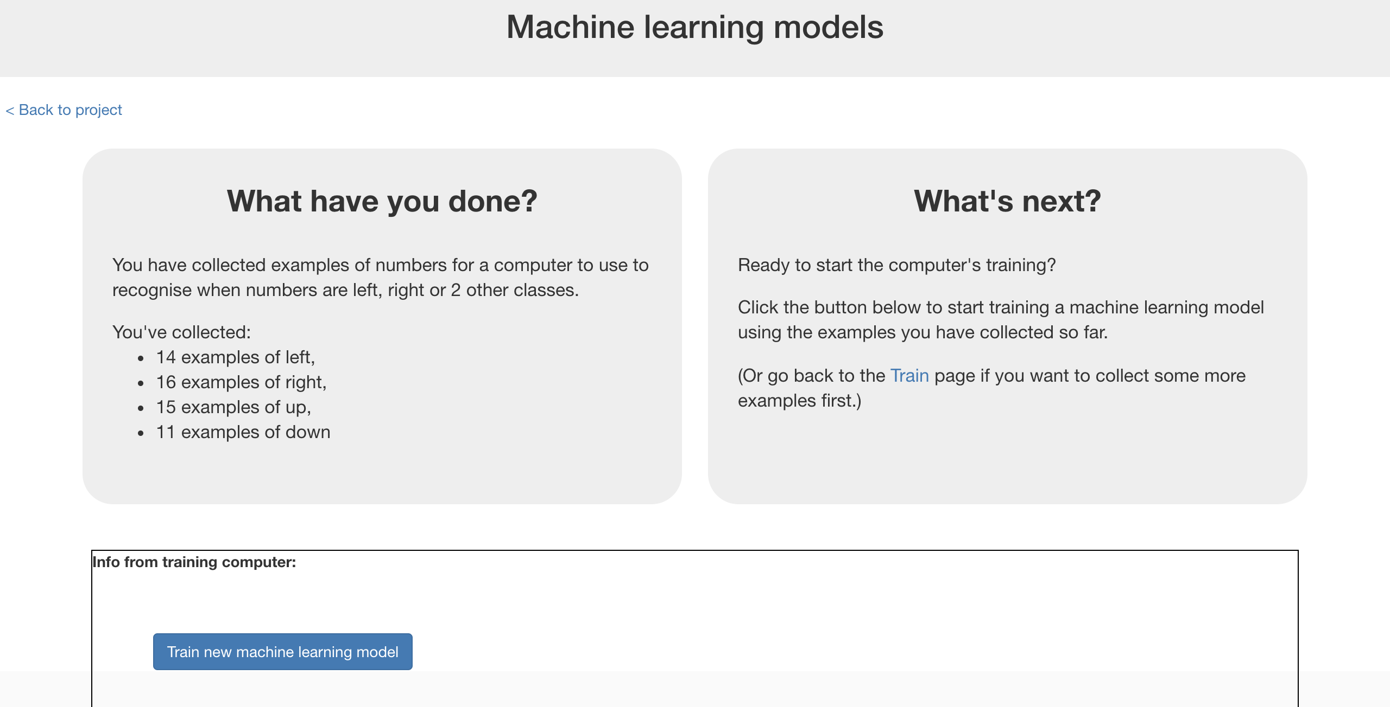

1. 回到Scratch視窗

*點選* ***< Back to project*** *->* ***Make*** *->* ***Scratch*** *->* ***Open in Scratch*** *->* ***File*** *->* ***Load Project***

Go back to the Scratch window.   
*If you accidentally closed it, you can get back to it by doing this:  
* Click the “****< Back to project****” link  
* Click the “****Make****” button  
* Click the “****Scratch****” button  
* Click the “****Open in Scratch****” button  
* Open the Scratch project you saved before, with “****File****” -> “****Load Project****”*

1. 點選『舞台』

Click on the Stage  
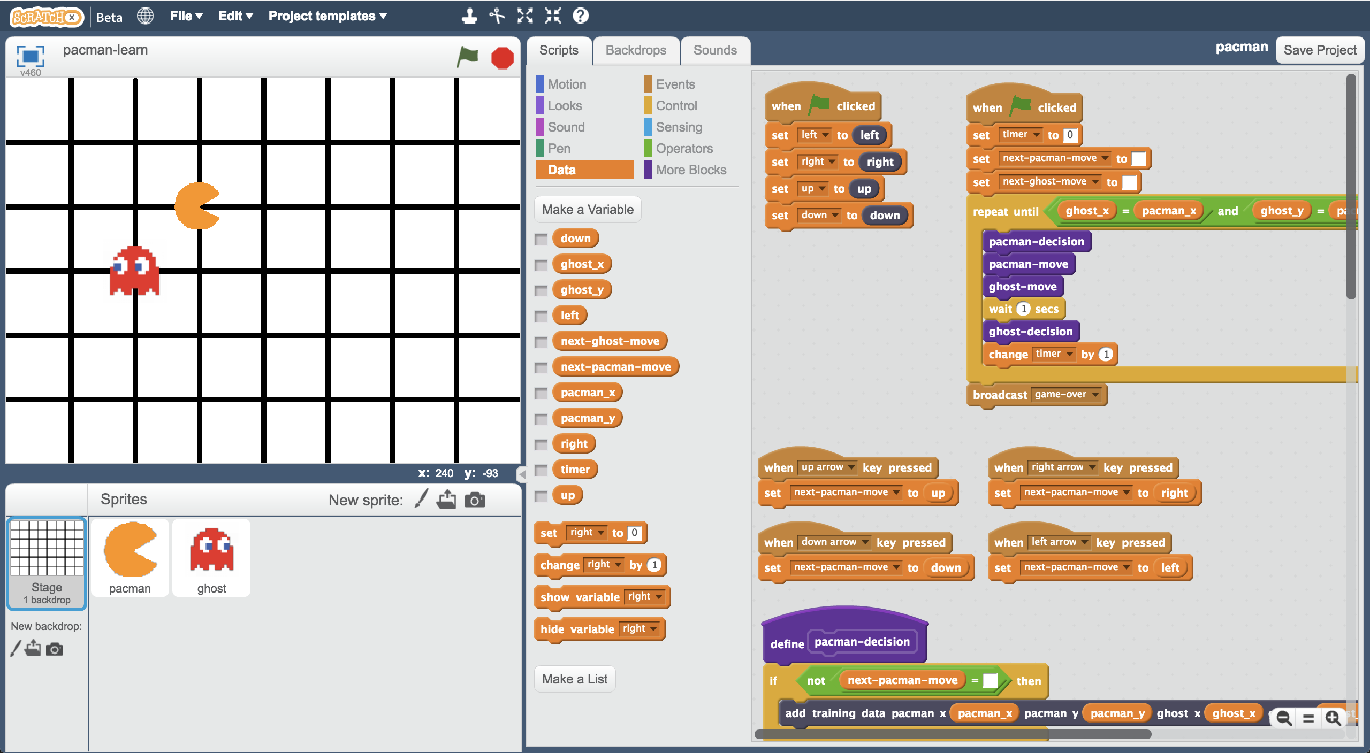

1. 刪掉『按下某方向鍵』的區域積木，因為現在輪到電腦玩了！

*在要刪除的積木上按右鍵 -> 刪除*

下面就是我們要刪掉的積木：

Delete the key-press scripts because it’s the computer’s turn!  
*(Delete a script by right-clicking on it and choose “Delete”)  
These are the scripts you don’t need any more:  
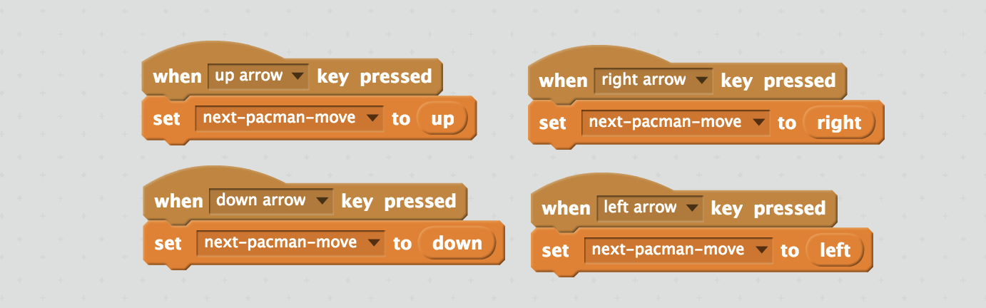*

1. 更新**pacman-decision**區域的程式積木：之前我們讓電腦蒐集遊戲過程的每個動作，現在我們要讓電腦使用機器學習模型。

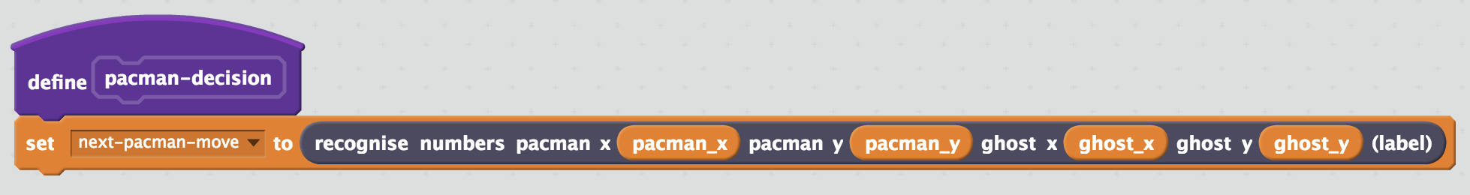 Modify the custom “**pacman-decision**” block  
*Instead of learning from what you are doing, now you want it to use your machine learning model*

1. 更新『當綠旗被點擊』區域的程式積木：移除『等待1秒』

更新後如下圖：

Modify the “Click Green Flag” script to remove “wait 1 second”. *You want the script to end up looking like this:  
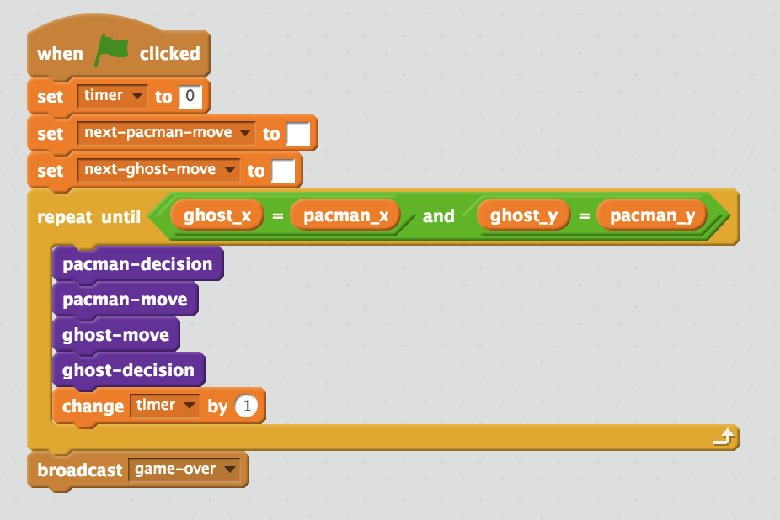*

1. 存檔

*點選檔案，再點選另存專案，檔案命名成pacman-play，用來提醒自己這是電腦自己控制小精靈的版本。*

Save your project  
*Click* ***File*** *->* ***Save project*** *Name the file “pacman-play.sbx” to remind yourself that this version of the project is where the computer controls Pac-Man.*

1. 開始測試囉！

*選擇全螢幕，再點擊綠旗*

*看你訓練出來的小精靈怎麼避開鬼*

Test the computer!  
*Click on full-screen again, and then the Green Flag.   
Watch the Pac-Man you’ve trained try to avoid the ghost.*

1. 打開**pacman-learn.sbx**專案

*點選****File*** *->* ***Load Project***

Open the training project “**pacman-learn.sbx**”.  
*Make sure you save your pacman-play project first!  
Click* ***File*** *->* ***Load Project***

1. 再多玩幾場遊戲，給電腦更多範例資訊

Train the computer some more by playing a few more games.

1. 回到訓練視窗

Go back to the training tool

1. 回到Learn & Test頁面

*點選* ***< Back to project*** *->* ***Learn & Test***

Go back to the “Learn & Test” page  
*Click the “****< Back to project****” link, and then click “****Learn & Test****”*

1. 點選**Train new machine learning model**

Click the “**Train new machine learning model**” button again

1. 回到Scratch視窗

*點選* ***< Back to project*** *->* ***Make*** *->* ***Scratch*** *->* ***Open in Scratch***

Switch back to the Scratch window.   
*If you accidentally closed it, you can get back to it by doing this:  
* Click the “****< Back to project****” link  
* Click the “****Make****” button  
* Click the “****Scratch****” button  
* Click the “****Open in Scratch****” button*

1. 開啟**pacman-play.sbx**專案

*點選****File*** *->* ***Load Project***

Open the testing project “**pacman-play.sbx**”  
*Click* ***File*** *->* ***Load Project***

1. 重新測試！

*這次小精靈有表現的比上次好嗎？*

Test the computer again  
*Did the computer do any better after more training?*

**完成了什麼？**

**What have you done?**

你訓練電腦玩小精靈遊戲，但你沒有告訴電腦遊戲規則，也沒有告電腦應該要避開鬼，更沒有告訴電腦場地邊界

（這些在原本的Scratch小精靈遊戲都有，但我們並沒有用在訓練機器學習模型上）

You’ve trained a computer to play Pac-Man.

You didn’t have to describe the rules to the computer.

You didn’t tell it that it should try to avoid the ghost.

You didn’t describe the boundaries of the board.

(The rules are in the Scratch game, but that doesn’t count – that wasn’t used in the machine learning model).

相反地，你蒐集了自己玩這個遊戲時的每個決定當作範例給電腦學習。

Instead, you showed it how you play, by collecting examples of decisions that you made when you play.

**小技巧**

**Tips**

**鬼打牆**

**Getting stuck in a loop**

有時候電腦很幸運，找到一個沿著邊界的環形路線，不會陷入鬼打牆的情況

Sometimes the computer can get lucky, and find a circular route around the board that gets into a never-ending loop.

當這種情形發生時，小精靈永遠不會輸！

When this happens, Pac-Man will never lose!

如果需要暫停遊戲，按下紅色的暫停按鈕

You can press the red stop button if you need to stop though.

**不要對敵人仁慈！**

**Don’t be kind!**

當你自己在玩遊戲時，很有可能對鬼好一點（怎翻啊）

You might be tempted to go easy on the ghost when you’re playing against it.

不要這麼做！電腦會從遊戲過程中學習，如果你玩得不好，電腦就不能學好。如果你想要讓電腦學好，**盡全力玩遊戲**！

Don’t. It is learning from the way that you play. If you don’t play well, it can’t learn how to play well.

If you want it to get better quickly, **play as well as you can**.

**持續訓練**

**Keep training**

電腦可以學習的範例越多，就可以學得越好。如果你有時間，多玩幾次遊戲並訓練一個新的模型吧。

The more examples the computer has to learn from, the better it will get. If you have time, play a lot of games and train a new model again.

**延伸活動**

**Ideas and Extensions**

現在你已經完成了這個專案，要不要試試下面的點子？或者，自己想一個？

Now that you’ve finished, why not give one of these ideas a try?

Or come up with one of your own?

**加入另一個鬼**

**Add another ghost**

只有一個鬼的時候，遊戲很簡單：小精靈只要想辦法一直避開這個鬼就可以了

The game is beatable with only one ghost – Pac-Man can just carry on avoiding the ghost forever.

但如果有第二個鬼在追小精靈的話，那遊戲就會變得很難了。

But with a second ghost chasing after Pac-Man, it will get really hard.

**調整遊戲邊界**

**Change the game board**

讓遊戲邊面更大一點，或者加入一些障礙物，小精靈和鬼都必須繞開這些障礙物。

Try making the game board bigger.

Or add obstacles that Pac-Man and the ghost will need to go around.

**設計屬於你自己的遊戲**

**Make your own game**

你不必侷限在小精靈遊戲。

要不要試試在Scratch設計你自己的遊戲，然後訓練一個機器學習模型讓電腦玩玩看？

This doesn’t only work with Pac-Man.

Why not make your own game in Scratch, and then train a machine learning model to be able to play it?